Fig 10 with revised calculation and (below) seperated into 3 regions (STTD & LIS=Transition)

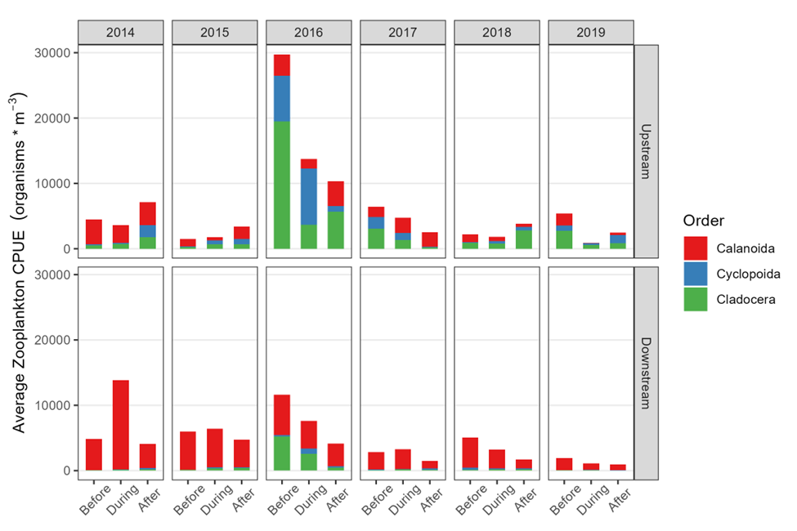

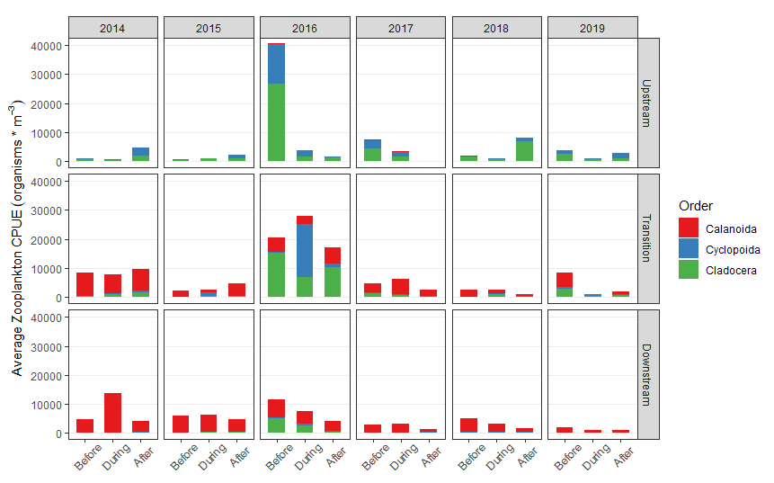

MS P forbesi plot:

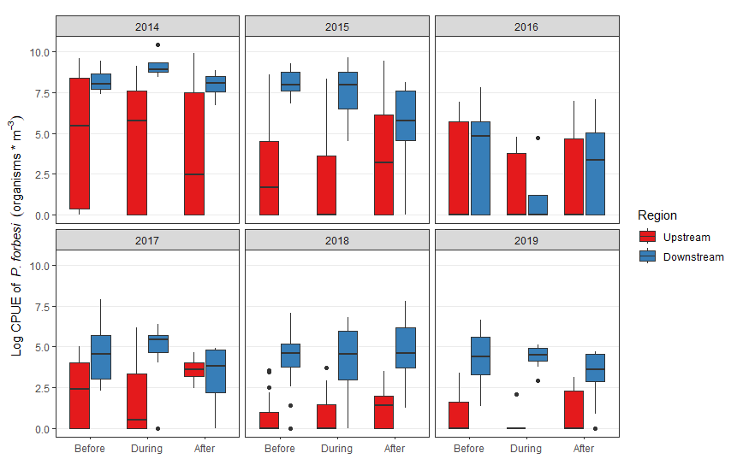

Same plot but for all Calanoids:

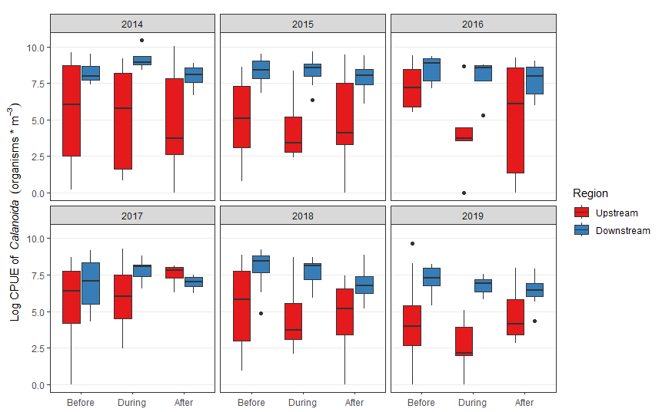

Now for just P forbesi copepodids:

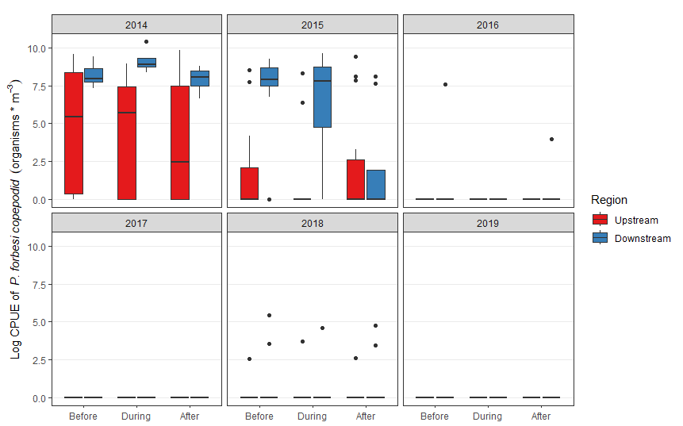

And Calanoid Copepodids:

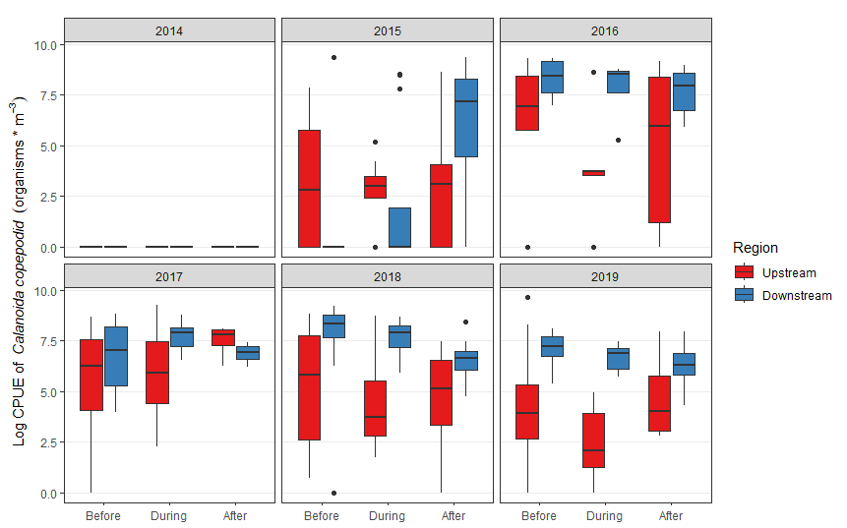

NMDS with a 3rd region comprising STTD and LIS called transition:

